I B.Tech II Semester Supplementary End Examinations October, 2023
NETWORK THEORY
Time: 150 Min (ECE) Max. Marks: 80M

SECTION – A
Answer Four question 4×10M=40M

- The Thevenin equivalent at terminals a-b of the linear network shown in Figure-1 is to be determined by measurement. When a 10-kΩ resistor is connected to terminals a-b, the voltage V_{ab} is measured as 6 V. When a 30-kΩ resistor is connected to the terminals, V_{ab} is measured as 12 V. Determine: (a) the Thevenin equivalent at terminals a-b, (b) V_{ab} when a 20-kΩ resistor is connected to terminals a-b.
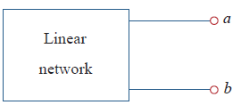
Figure-1

- An industrial load is modeled as a series combination of a capacitance and a resistance as shown in Figure-2. Calculate the value of an inductance L across the series combination so that the net impedance is resistive at a frequency of 50 kHz.
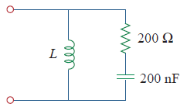
Figure-2
3. (a) If the switch in Figure-3 has been open for a long time and is closed at t=0 find v_{o}(t).
(b) Suppose that the switch has been closed for a long time and is opened at t=0 find v_{o}(t).
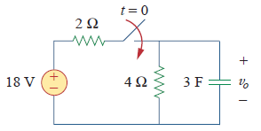
Figure-3
4. Referring to Figure 4,
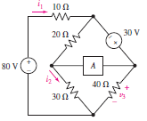
Figure 4
- Ascertain whether nodal or mesh analysis is more appropriate in determining i₂ if element A is replaced with a short circuit, then carry out the analysis.

b) The element marked A in the circuit of Fig.4 is replaced by a 5.5 V independent voltage source with the positive reference terminal connected to the common node of the 20 Ω and 30 Ω resistors. Figure out whether mesh or nodal analysis is more straightforward for determining the voltage marked v₃, then carry out the analysis.

SECTION - B
Answer Two questions 2×20M=40M

5. The circuit are given below.
a) Obtain the Y-parameters of the two-port network in Figure-5-1.
b) At ω=1 rad/s, find the transmission parameters of the network in Figure-5-2.
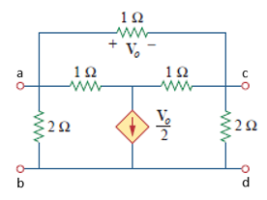  Figure-5-1 | 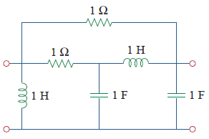  Figure-5-2

6. a) The circuit in figure 6(a) below is to control the speed of a motor such that the motor draws currents 8 A, 6 A, and 2 A when the switch is at high, medium, and low positions, respectively. The motor can be modeled as a load resistance of 50mΩ. Workout for suitable series dropping resistances R₁, R₂, and R₃.
b) Suppose the motor current is measured using an ammeter model, consists of an ideal ammeter in series with a 20-Ω resistor. It is connected with a current source and an unknown resistor Rx as shown in figure 6(b). The ammeter reading is noted. When a potentiometer R is added and adjusted until the ammeter reading drops to one half its previous reading, then R = 55Ω. What is the value of Rx?
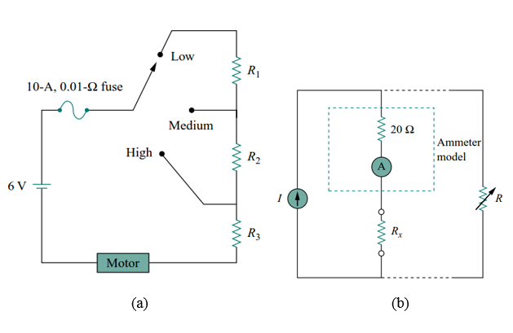
Figure-6

